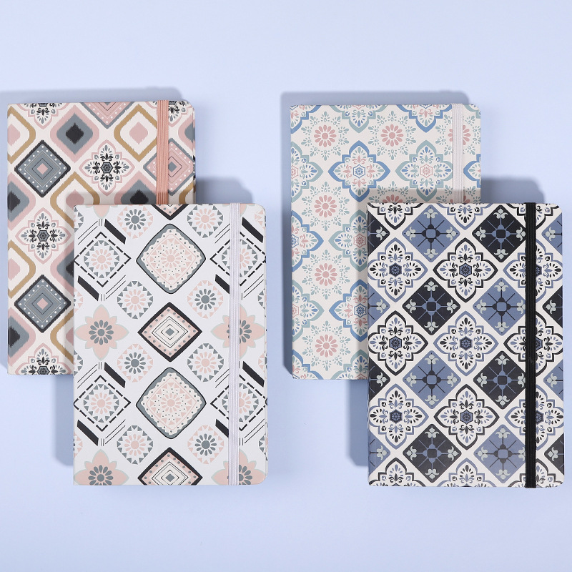

**MOSAIC STYLE JOURNAL**

RYANA CALENDARS is selling wonderful MOSAIC STYLE journals !at reasonable prices. It contains beautiful and designable covers!

**RS 770**